Baltimore County Public Schools
Communications and Community Outreach
Office of Family and Community Engagement
443-809-0365
http://www.bcps.org/offices/FamilyCommunityEngagement.htm

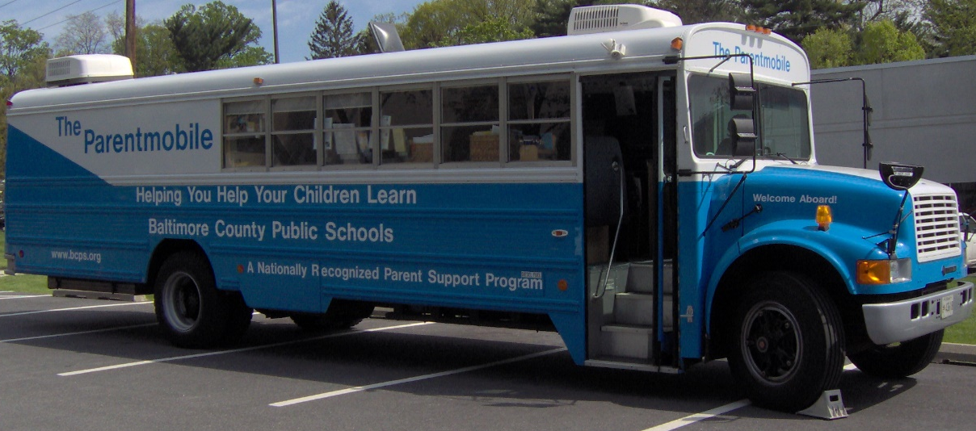
Visit the Parentmobile at
Winfield Elementary School
Wednesday, November 14, 2018
10 AM to 12 Noon
American Education Week
Baltimore County Public Schools’ Parentmobile is a traveling educational resource center for parents and families. Visitors can…
- Learn about Baltimore County Public Schools’ curricula.
- Select resources and materials to assist learning at home.
- Visit Baltimore County Public Schools’ Web sites.
- Learn about community resources that support education.
- Learn about resources that support families of students with special needs or limited English proficiency.
Parents and family members are encouraged to board the big blue bus and find additional ways to support their children in their academic achievement.
